***INTERNETWORKING ESSENTIALS- CSE307***

***Section – K23UP***

***Submitted by:***

***Reddy Manjunath***

***Registration & Roll Number:***

***12312640, 7***

***CA - 2***

***DATE: - 25/04/2025***

***In partial fulfilment for the requirements of the award of the***

***degree of***

***“B. Tech CSE Data Science and Machine Learning” ***

***“School of Computer Science and Engineering”***

***Lovely Professional University***

***+ Phagwara, Punjab***

**Project7: You are hired as a network engineer for XYZ Solutions, a midsized**

**enterprise with a 5-floor office building. Each floor is equipped with a**

**different number of computers, like floor 1 has 33895, floor 2 has 3789,**

**floor 3 has 178, floor 4 has 33, and floor 5 has 27. Configure the HTTP**

**server on floor 1, the DNS server should be connected on floor 3, the FTP**

**server should be connected on floor 2, and the DHCP and Email servers of the**

**company are on floor 5. The organization requires a well-structured network to**

**ensure efficient communication and scalability.**

**Network Design Requirements:**

**1. Topology Selection: Design a Star topology for the first 3 floors and a Bus**

**topology for the remaining floors, considering performance and fault tolerance.**

**(Just connect 7 computers on each floor instead of the given requirement, as we**

**are not able to do this in Cisco Packet Tracer.)**

**2. IP Addressing Scheme: The company has decided to use Class B private**

**IPv4 addresses for the first 3 floors and Class A public for the remaining**

**floors, following a classless addressing scheme that is VLSM. Allocate IP**

**addresses properly for each floor, ensuring uniqueness.**

**3. Routing Strategy for Inter-Floor Communication & Connectivity:**

**Recommend a routing approach that is Dynamic for inter-floor**

**communication.**

**• Design how the floors will be connected for seamless interdepartment**

**communication.**

**• Suggest the appropriate network devices (e.g., switches, routers, access**

**points) and their placement.**

**• If using dynamic routing, use RIP routing protocol.**

**• If using static routing, define the static routes for efficient data flow.**

**• The minimum number of routers to be used should be 4 and the**

**maximum 5.**

**• Specify the number of default gateways along with IP addresses.**

**• Specify each SUBENTWORK with proper Subnetwork address, host IP**

**range, and broadcast address.**

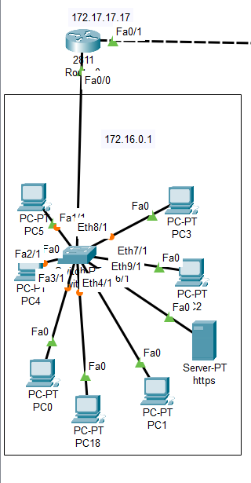

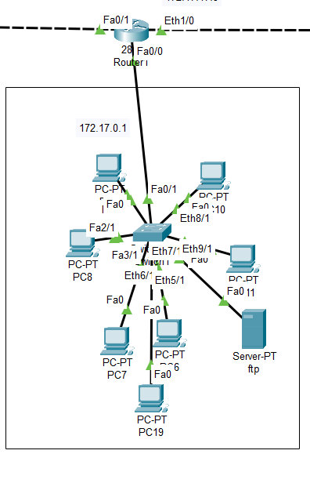

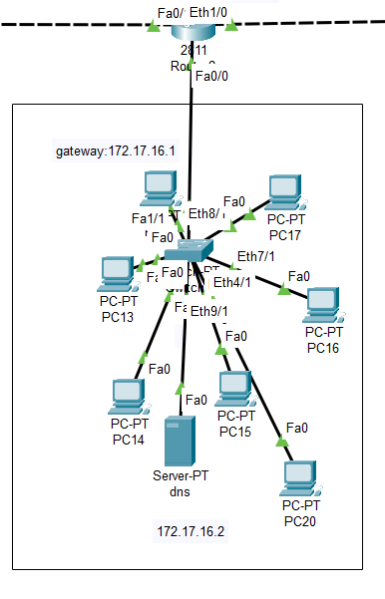

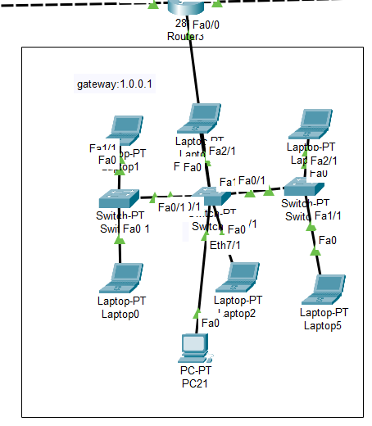

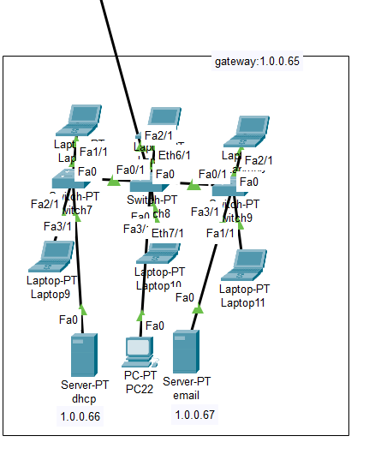

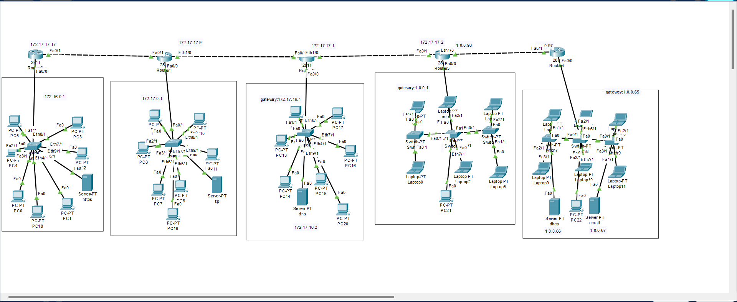

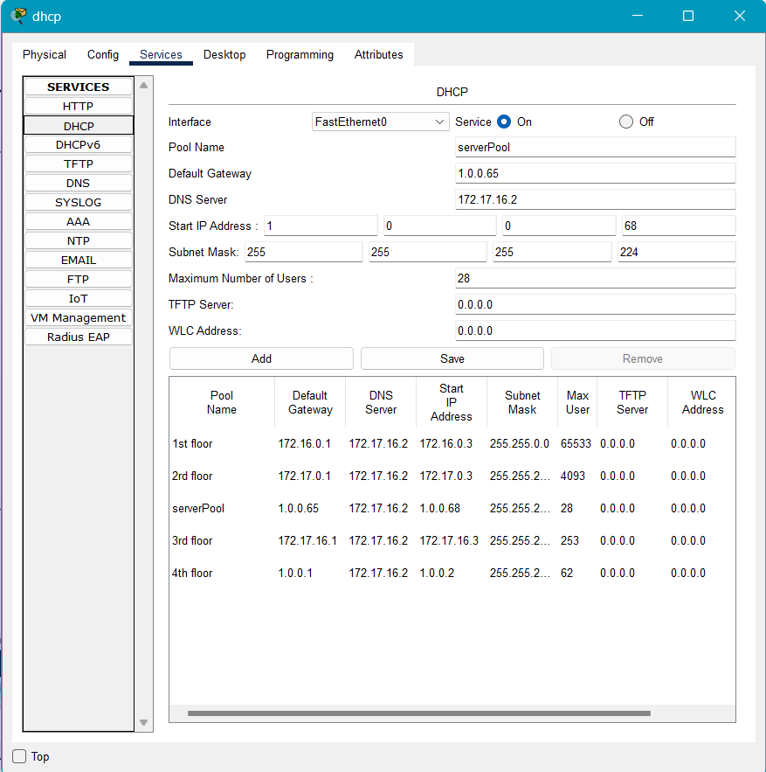

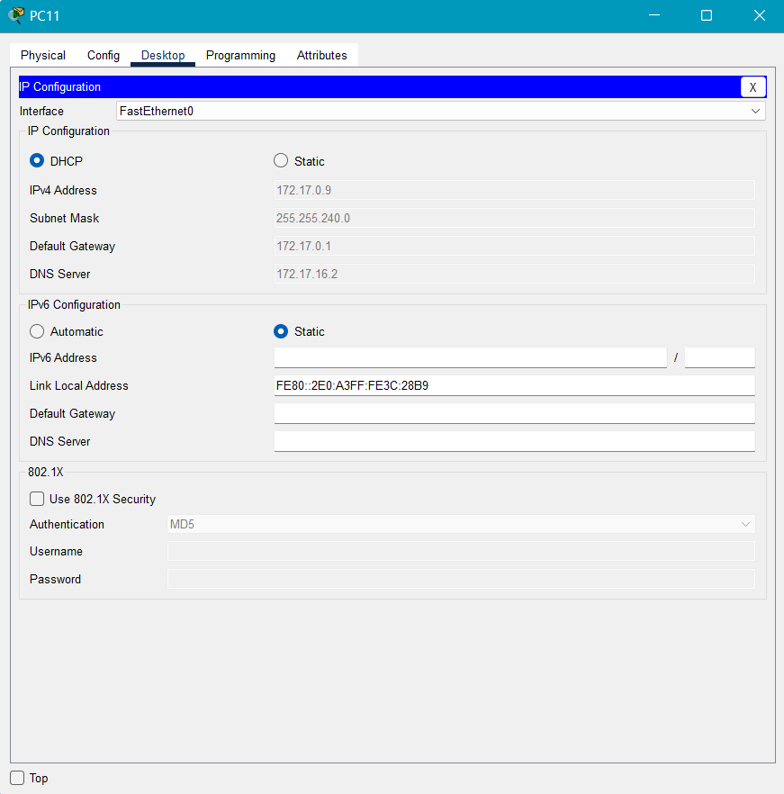

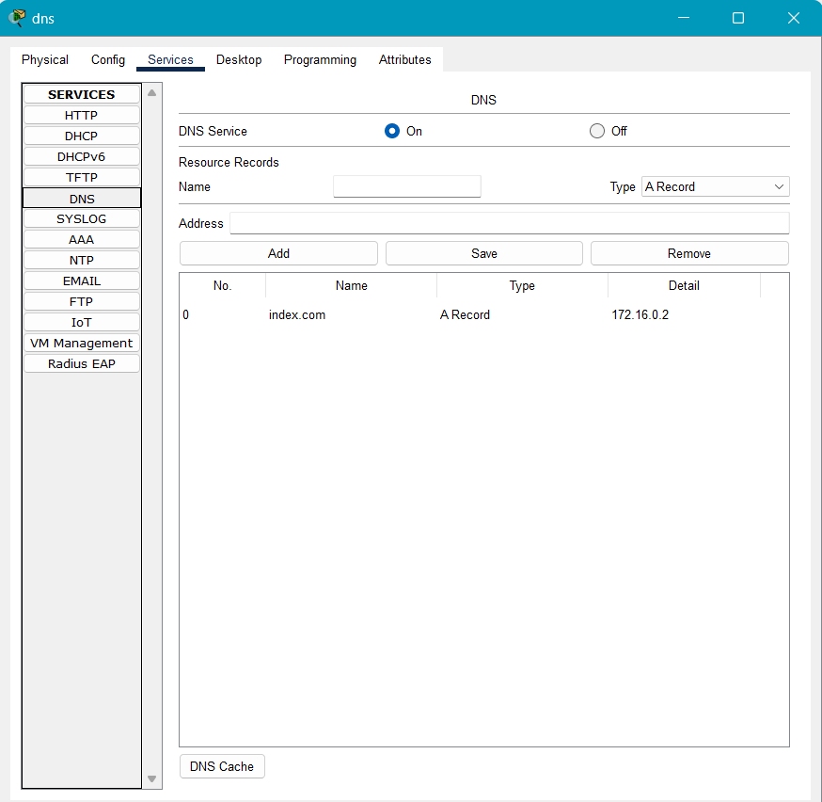

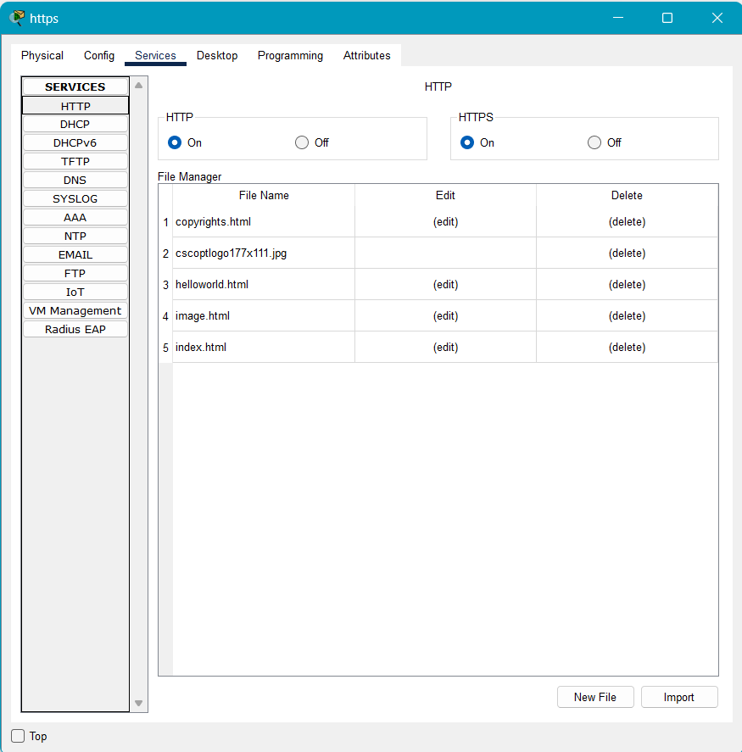

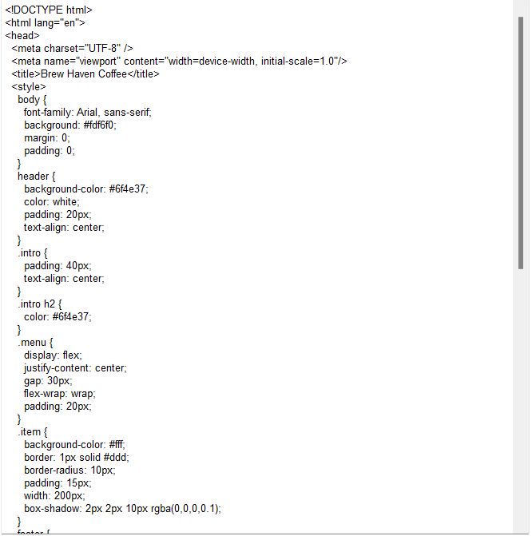

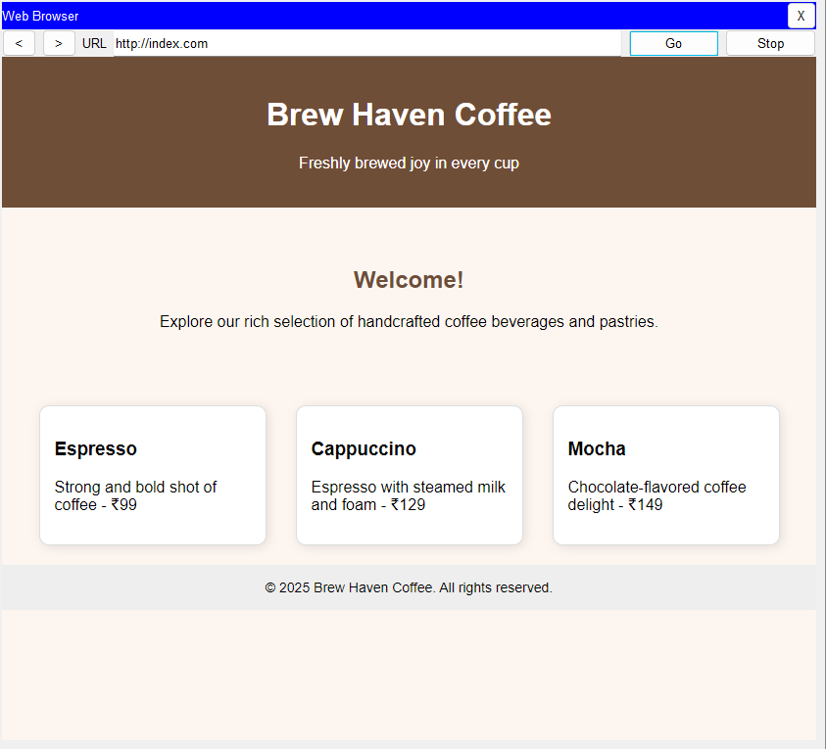

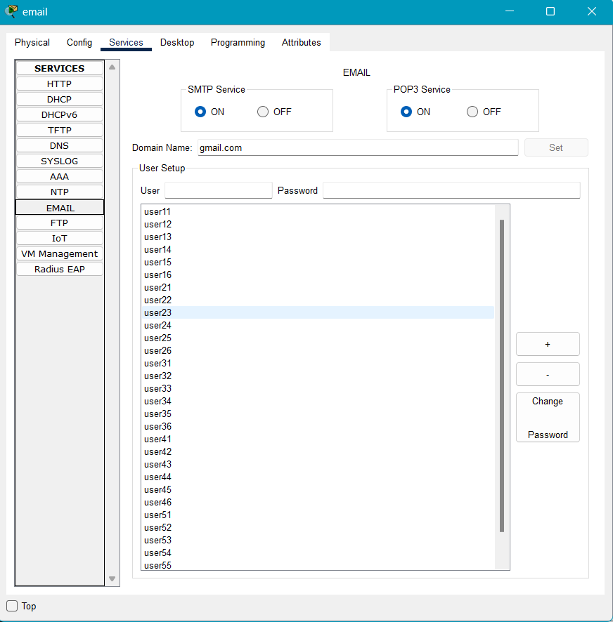

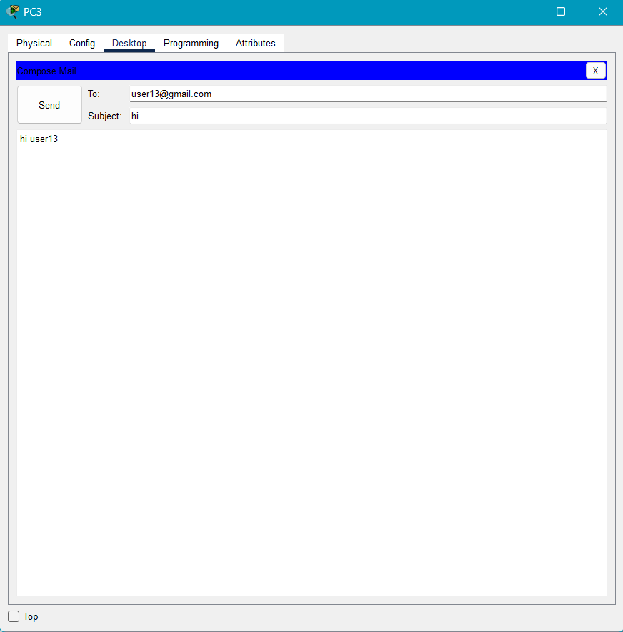

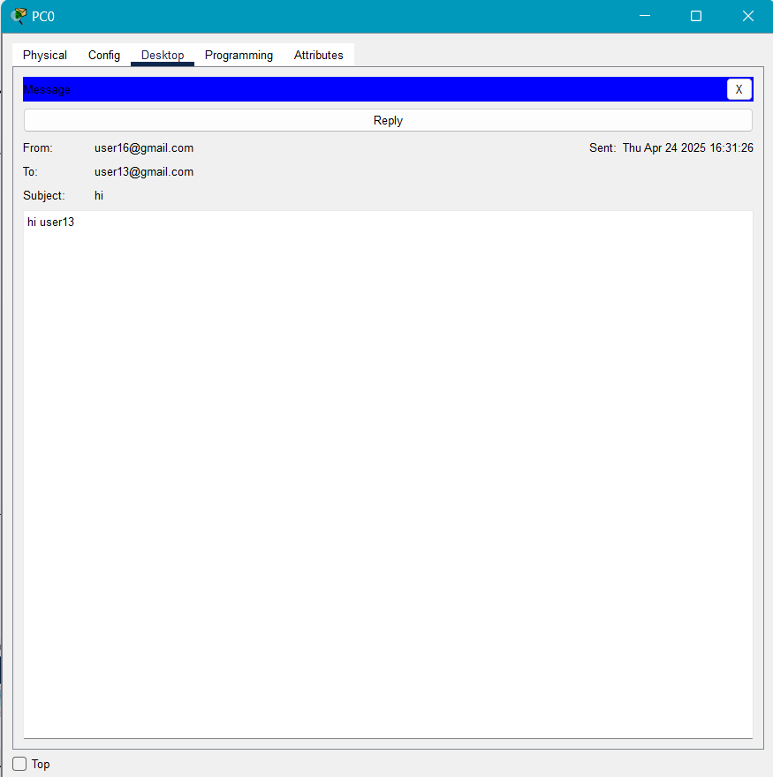

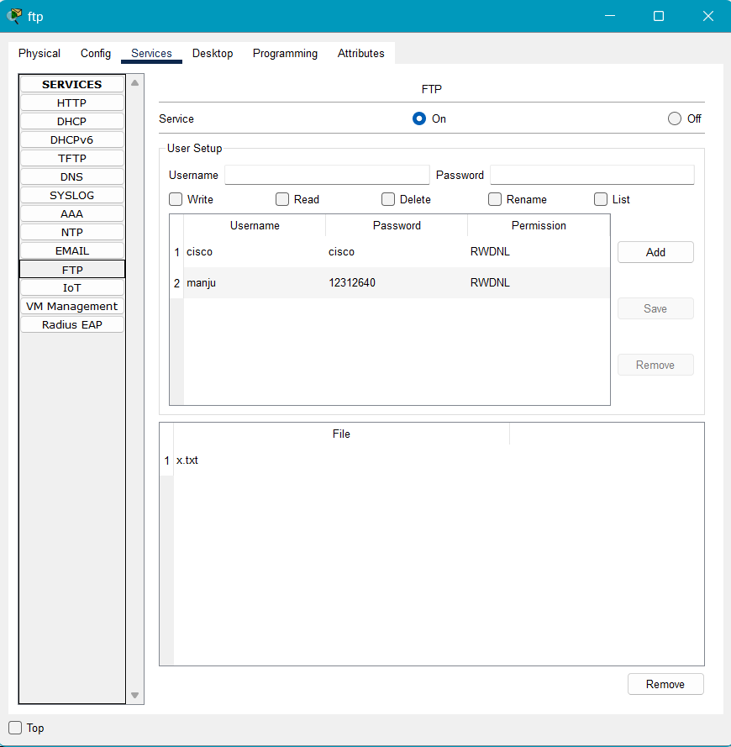

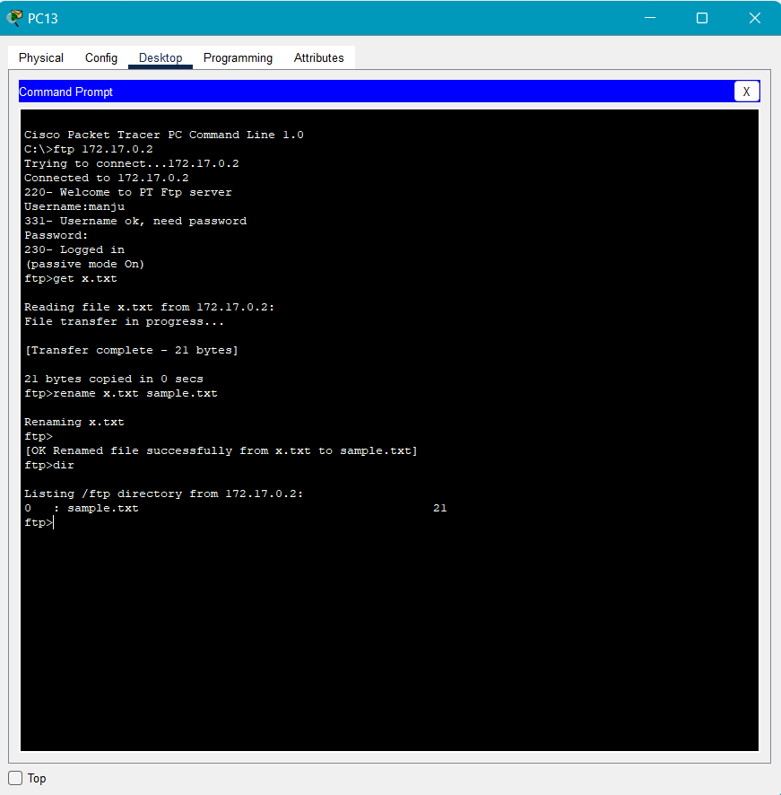

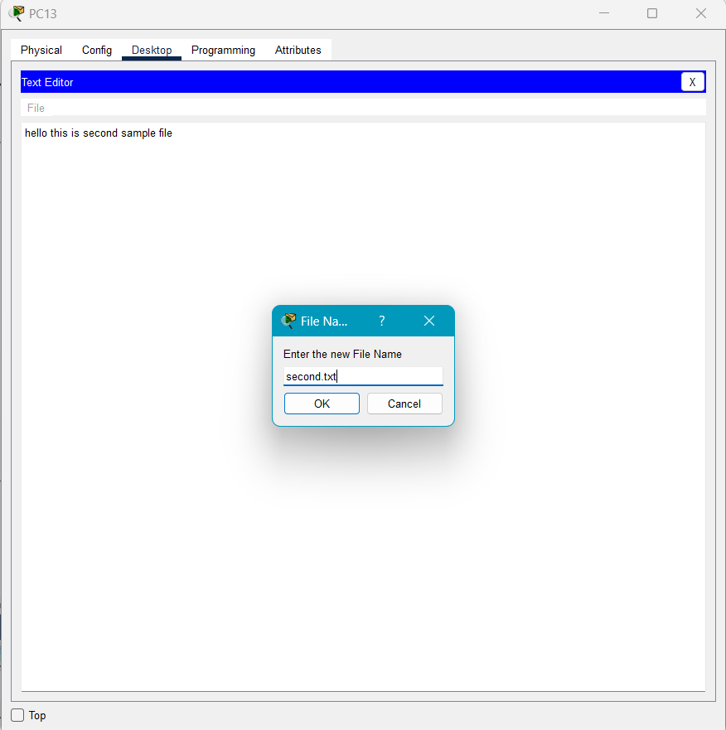

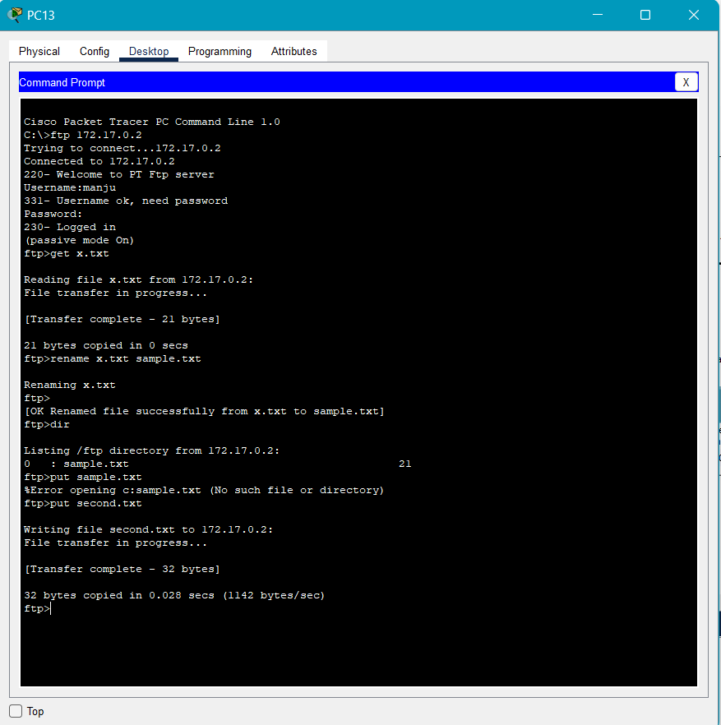

GITHUB LINK: - <https://github.com/AkshitSalgundi/Networking_CA2>